Muhammad Umar Farooq
Writing Task 1
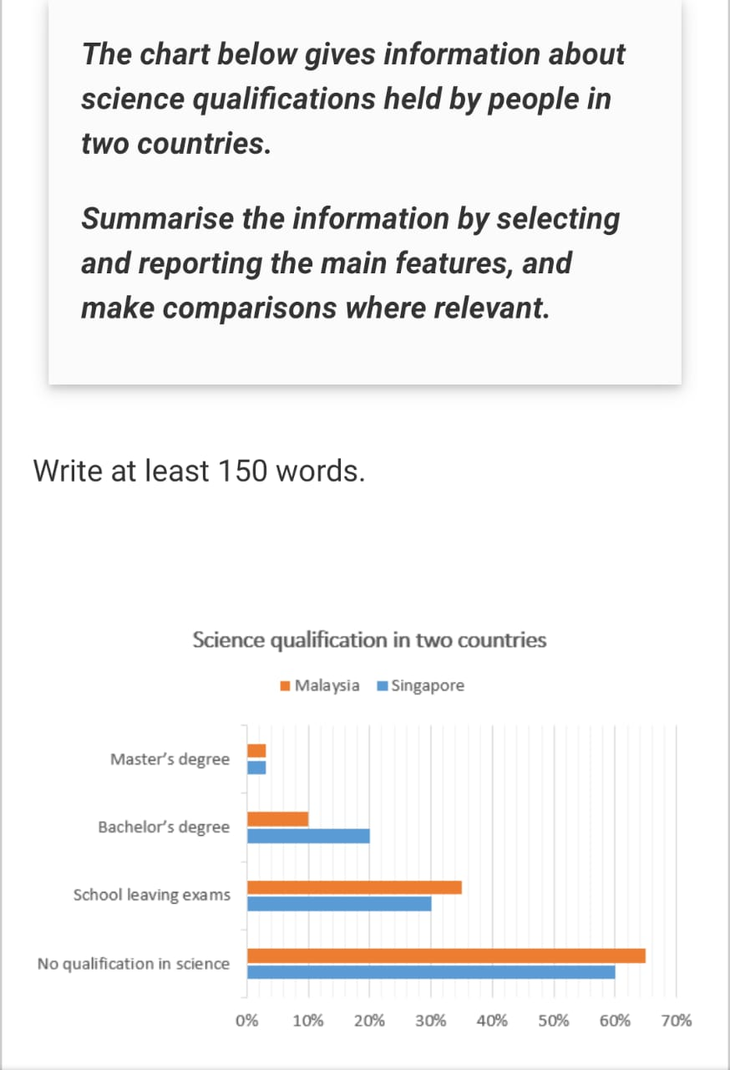

The chart provides information about the scientific education held by public in Malaysia and Singapore.
Overall, both countries had the significant proposition of the population without qualifications in science, with Malaysia having a slightly higher percentage. However, Singapore exceeding the number of students holding the Bachelor’s degree in science. Moreover, science learner in Master’s degree is the approximately stabilized in both countries.
Looking at the details, Malaysia and Singapore had a higher proportion of people who did not study science, with Malaysia at 60% and Singapore at approximately at 65%.
In Contrast, Malasia had higher percentage of student who completed their school leaving exams, with 35%, while Singapore had lower percentage at 30%.
However, Singapore had 20% of students with a bachelor’s degree, while Malaysia had only 10% of the students with a bachelor’s degree in science.
Enrollment in master’s degree remains steady, with fewer than 10% students in both countries holding a master’s degree in science.

